Rough Phase proposal of blockchain in insurance dashboard of vehicle

Agenda :

we propose a tamper-free ledger based platform for insurance record and resale value track vehicles in general .

This record system can include all aspects of transactions pertaining to vehicle.

It not only would improve the experience around proving insurance, but also act as evidence in the event of a dispute and also helps the second hand buyer to assess the condition of the vehicle and match it with the number quotes during reselling.

This ledger can have extended services around providing a clean driving record.

Individual drivers, dealers, insurance companies, vehicle agencies are all stakeholders of this blockchain based solution.

**WHY BLOCKCHAIN HERE :**

Blockchain is trustworthy and helps reduce fraud

Blockchain helps in more automation by rejecting the use of paperwork in the industry

Blockchain helps in storing more data securely

**Use cases:**

* Registries of high-value items and warranties
* Know-your-customer (KYC) and anti-money laundering (AML) procedures
* Parametric (index-based) products
* Reinsurance practices
* Claims handling
* Distribution methods
* Peer-to-peer (P2P) models

**Proposed Model considering use cases:**

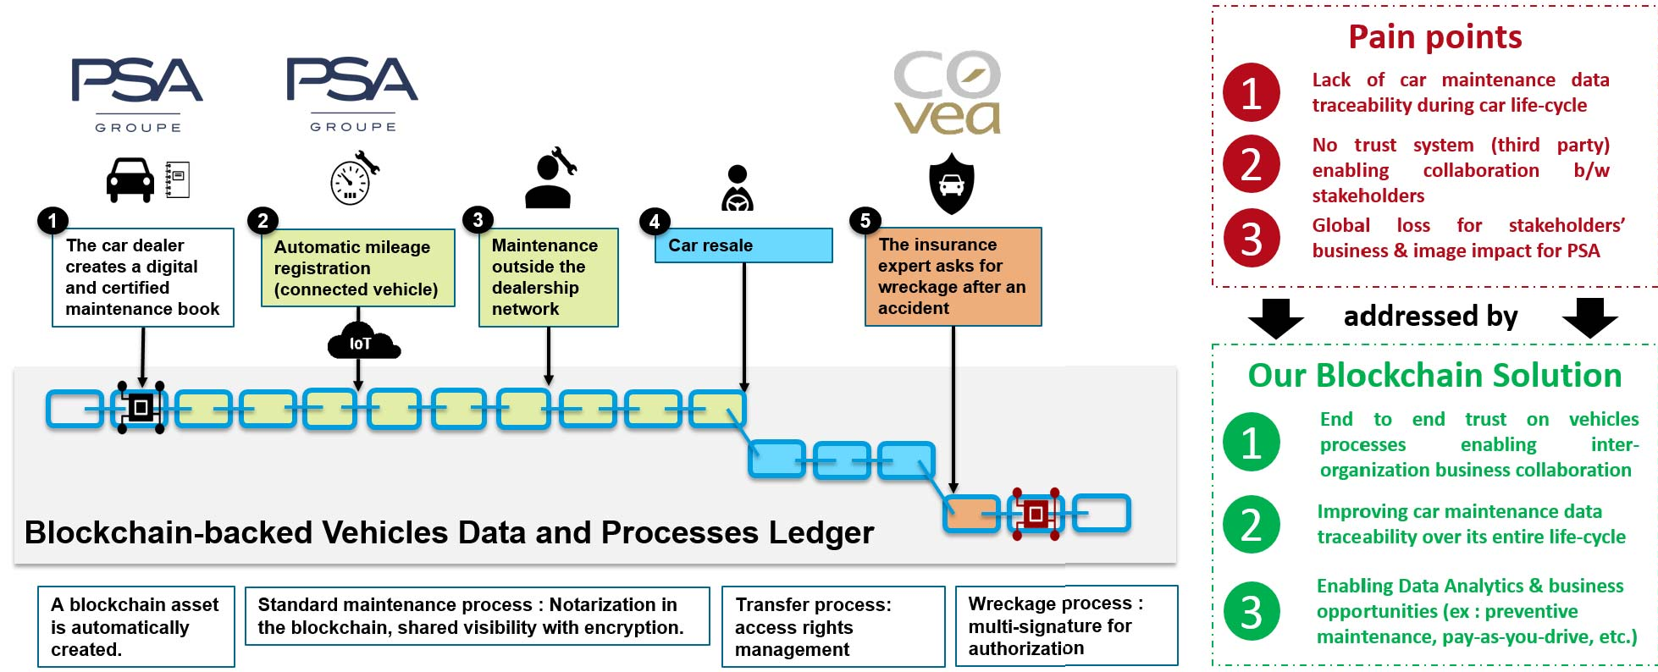

Overview of technical architect

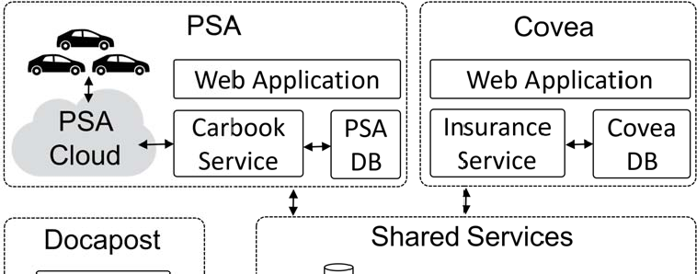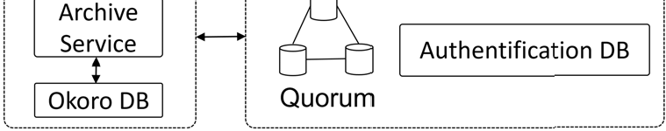

Here

PSA : Traceabl

Covea : Insurance company(name)

Docapost : 3rd party company

As we discussed about our proposal no lets get familiar with the steps followed during reclaiming of insurance

Insurance claim submission on our platform:

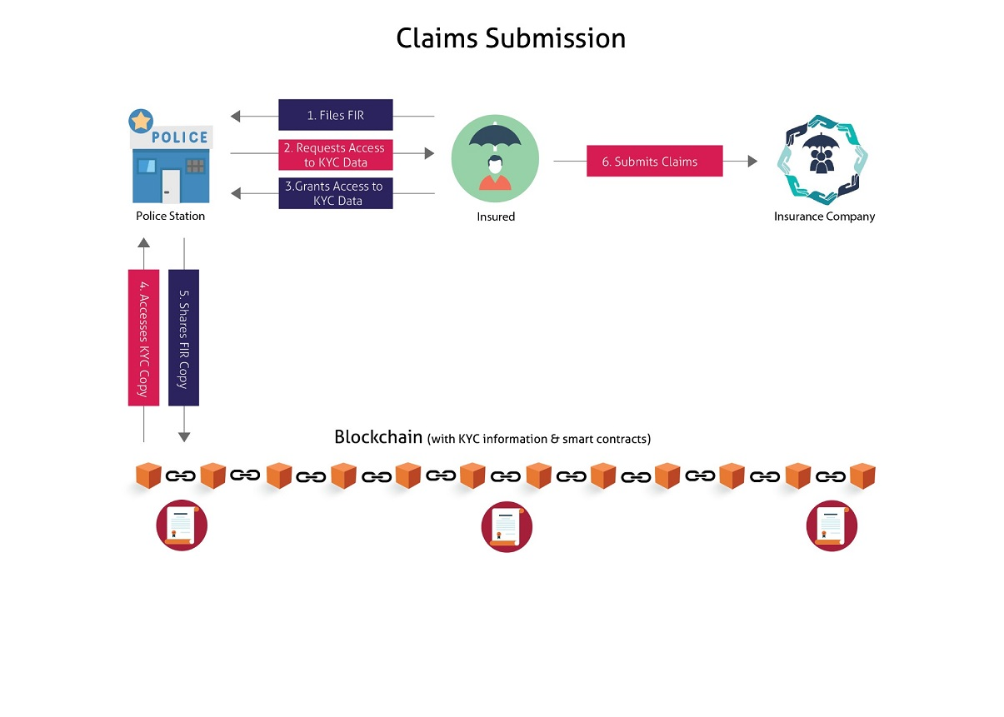

1. The Insured files the First Information Report (FIR) at the local police station and submits evidence [registration number and photos of his or her vehicle as well as the other vehicle(s) involved, contact details of witnesses and so on].
2. The Police Station requests access to the Insured’s KYC data on the blockchain. A similar request for access will be submitted to the owner or driver of other vehicle(s) involved.
3. Insured provides access to the relevant KYC data. The owner or driver of other vehicle(s) involved also follows a similar process.
4. A copy of the relevant KYC data is made available to the Police Station.
5. Once the FIR is filed by the Police Station in its online system, a copy of the FIR is shared with the Insured’s KYC blockchain. A copy of the same FIR is made available to the owner or driver of other vehicle(s) involved.
6. The *Insured* approaches the *Insurer* for submitting claims via an [AI chatbot](https://www.mindtree.com/blog/how-artificial-intelligence-re-inventing-insurance-industry) interface to submit evidence, photos and answers to questions. If the Insured has sustained bodily injuries during the accident, the Insurer will need to be informed of this.

When vehicle damaged

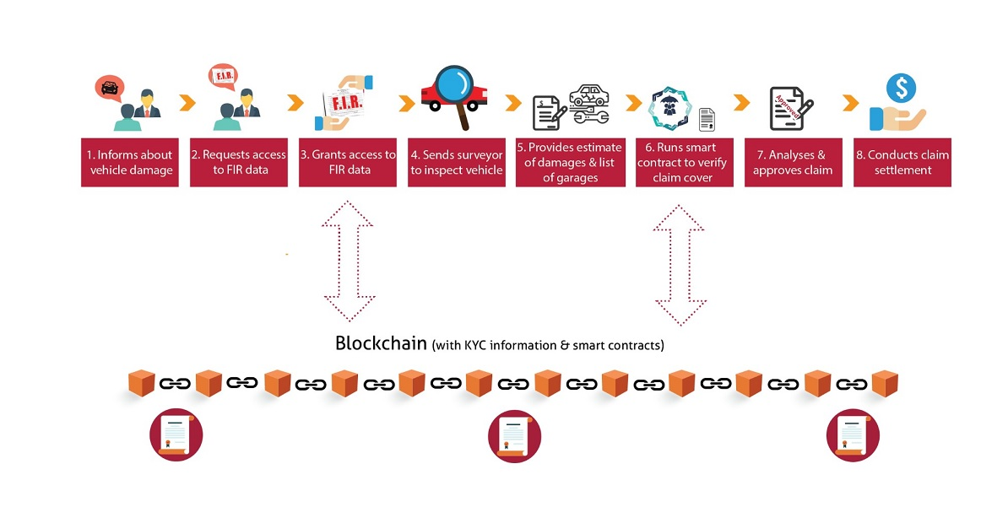

1. At the time of submitting claims, the Insured informs Insurer about vehicle damage due to the accident.
2. The Insurer requests access to the Insured’s FIR data residing on the blockchain.
3. Insured provides access to the relevant FIR data. A copy of the relevant FIR data is made available to the Insurer.
4. The Insurer sends a surveyor to inspect the vehicle and provides an estimate of the damage.
5. The Insurer also provides a list of its approved garages that can address the repairs.
6. The Insurer then runs a smart contract to verify whether the submitted claims are covered in the policy and calculates a claim amount.
7. The Underwriter reviews and approves the claims and the claims transaction and related details are updated on the blockchain.
8. If the Insured selects a garage from this list, the claim amount will be transferred directly to the garage (cashless claim).
9. If the Insured selects an external garage (that is not present on the Insurer’s list), the claim amount will be reimbursed in the Insured’s bank account.